Reducing the electricity storage volumes/units

**Introduction:**

The increasing penetration of electric vehicles (EVs) presents a unique opportunity to address challenges related to electricity storage and grid stability. Grid-to-Vehicle (G2V) technology flips the script on traditional energy flow, allowing EVs to act as both consumers and suppliers of electricity. This two-way power exchange creates the potential to significantly reduce reliance on conventional electricity storage solutions like generators, leading to a more sustainable and resilient power grid.

**Leveraging EV Batteries for Home Energy Storage (V2H):**

* **Atomic Implementation:**
  + **Hardware:** V2H systems typically involve a bi-directional charging station installed at the homeowner's residence. This station connects the EV to the home's electrical system and facilitates two-way power flow. Smart meters monitor energy consumption and communicate with the utility grid.
  + **Software:** An intelligent energy management system (EMS) acts as the brain of the V2H system. The EMS considers factors like electricity prices, weather forecasts, grid demand, and desired EV range to optimize charging and discharging schedules.
    - During off-peak hours with lower electricity rates, the EMS prioritizes charging the EV battery.
    - When peak hours hit, and electricity costs surge, the EMS can initiate a controlled discharge of the EV battery to supplement home energy needs. This not only reduces reliance on the grid but also allows homeowners to potentially profit by selling excess power back to the utility.
* **Benefits:**
  + **Reduced Generator Usage:** Homes with V2H systems can utilize stored EV battery power during outages, eliminating the need for individual generators. This translates to lower emissions, noise pollution, and dependence on fossil fuels.
  + **Cost Savings:** Utilizing off-peak electricity rates for charging and selling excess power back to the grid during peak hours can create cost benefits for EV owners. Utilities may offer additional incentives to encourage participation in V2G programs.

## **Home Energy Backup Algorithm with G2V Technology**

This algorithm utilizes an EV battery and G2V technology for home energy backup, reducing reliance on generators.

**Mechanism:**

1. **Data Collection:**
   * The system continuously monitors:
     + Home energy demand (real-time power usage)
     + Grid power availability (checks for outages)
     + EV battery state of charge (SOC)
     + Grid electricity prices (if participating in energy trading)
   * Historical data on usage patterns and outage frequency can be used for prediction.
2. **Decision Making:**
   * An optimization algorithm analyzes the collected data and makes decisions based on pre-defined priorities:
     + **Priority 1: Maintain Critical Loads:** Ensure enough EV battery reserve to power critical home appliances (fridge, medical equipment) during outages.
     + **Priority 2: Minimize Cost:** If the grid is operational, prioritize charging the EV during off-peak hours for lower electricity costs.
3. **Control Actions:**
   * Based on the decision, the algorithm triggers actions:
     + **Grid Outage:**
       - If a grid outage occurs and home demand exceeds critical load, the system automatically switches to discharge power from the EV battery to meet remaining home energy needs.
     + **Grid Available:**
       - If the grid is operational:
         * During off-peak hours, the system prioritizes charging the EV battery.
         * During peak hours, the system might limit charging or even discharge power back to the grid (V2G) if profitable and battery SOC allows.

**Explanation:**

* The algorithm prioritizes critical home appliance use during outages, ensuring essential needs are met even with a depleted EV battery.
* By encouraging off-peak charging, the system reduces strain on the grid during peak hours and lowers electricity costs.
* Participating in V2G (optional) provides additional income to the homeowner while contributing to grid stability.

**Sample Data for average data household power consumption and EV Backup potential.**

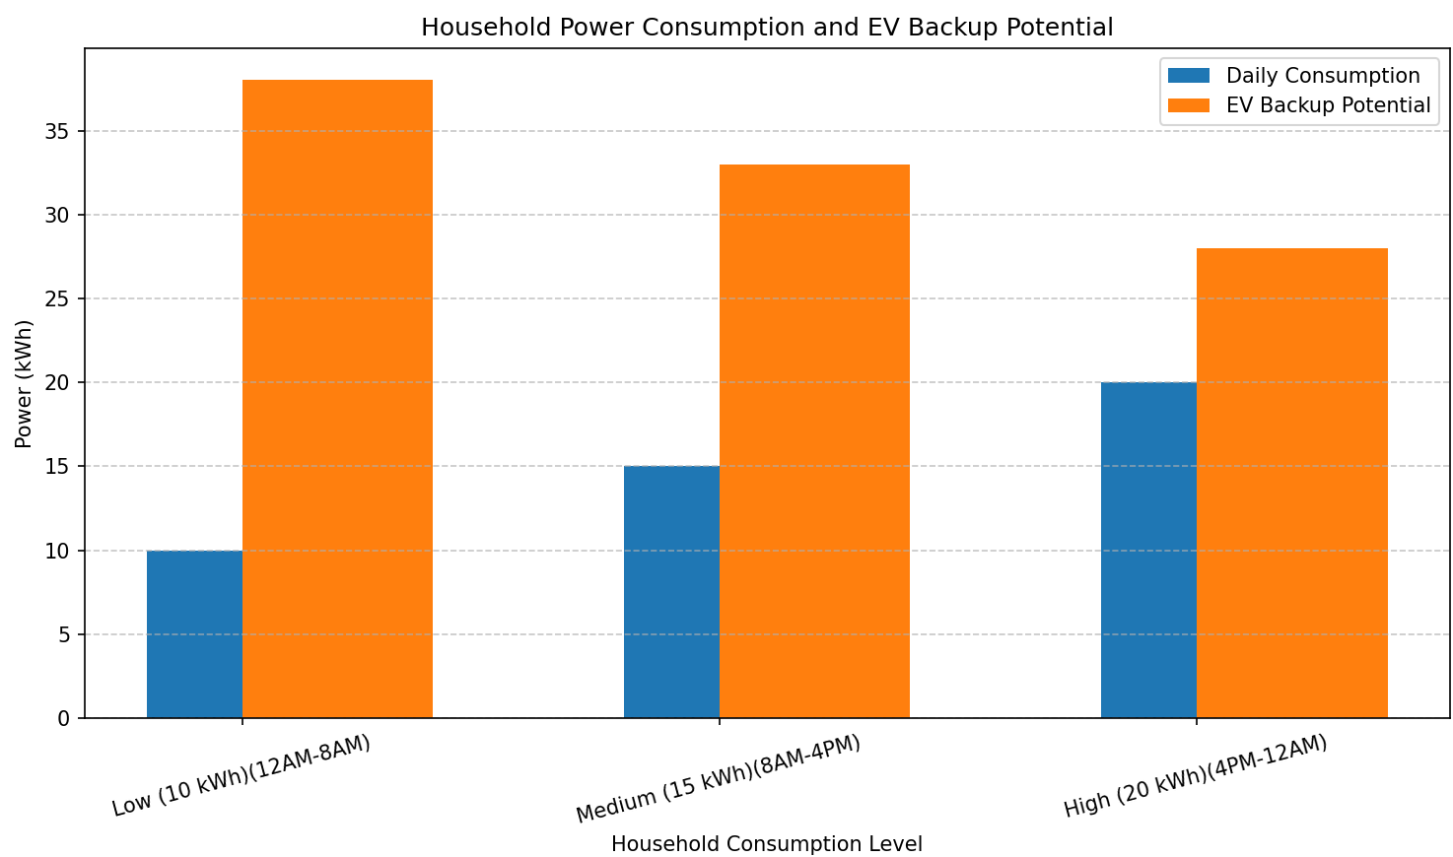

**Analyzing the power consumption of a set of household appliances and comparing it to the capacity of a 40 kWh battery commonly found in electric vehicles (EVs).**

**Appliance Power Consumption**

The following appliances are considered, with their average wattage:

* Fans (4): 75 watts/fan * 4 fans = 300 watts
* Tubelights (4): 50 watts/tubelight * 4 lights = 200 watts
* Refrigerator: 400 watts
* Water Pump Motor: 500 watts
* Other Appliances: 500 watts

**Total Appliance Power Consumption**

Total Power Consumption = 300 watts + 200 watts + 400 watts + 500 watts + 500 watts = 1900 watts

**Converting Watts to Kilowatt-hours (kWh) per Hour**

Total Power Consumption (kWh/hour) = 1900 watts / 1000 watts/kWh = 1.9 kWh/hour

**Comparison with 40 kWh EV Car Battery**

Battery Life (hours) = Battery Capacity (kWh) / Appliance Consumption (kWh/hour)

Battery Life = 40 kWh / 1.9 kWh/hour ≈ 21.05 hours

**Conclusion**

This set of appliances consumes roughly 1.9 kWh per hour. A 40 kWh EV battery could power these appliances for approximately 21.05 hours. Therefore, even using just 10% of your car's battery capacity (4 kWh) could keep essential appliances running for about 2 hours, which typically covers the duration of a power outage.

According to the US Energy Information Administration. The x-axis of the graph shows the size of the home in square feet, while the y-axis shows the average daily electricity usage.

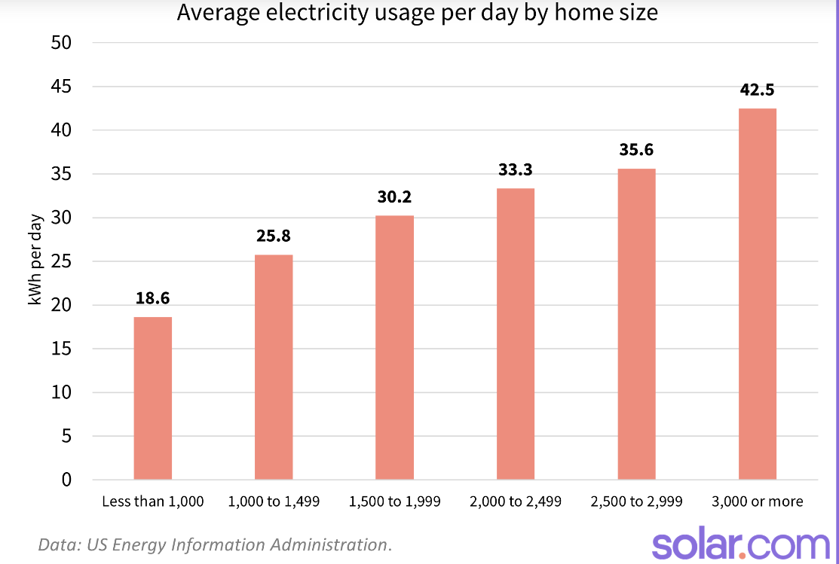

Here are some key takeaways:

* The average US home uses about 30 kWh of electricity per day.
* Homes smaller than 1,000 square feet use an average of 18.6 kWh per day.
* Electricity usage increases as home size increases. Homes greater than 3,000 square feet use an average of 42.5 kWh per day, more than double the amount of electricity used by homes under 1,000 square feet.

It's important to remember that these are just averages. Several factors can influence how much electricity a home uses, including:

* Climate: Homes in hot or cold climates will use more energy for heating and cooling.
* Number of occupants: Homes with more people will generally use more electricity.
* Appliance usage: Homes with energy-efficient appliances will use less electricity.
* Insulation: Homes that are well-insulated will lose less heat and air conditioning, which can save energy.

**How are EV batteries a better option for the environment?**

**Emissions:**

* **Generators:** These typically run on gasoline or diesel, releasing harmful pollutants like nitrogen oxides and particulate matter into the air. These contribute to smog, acid rain, and respiratory problems.
* **EVs:** Electric vehicles produce **zero tailpipe emissions** while driving. However, their environmental impact depends on the electricity source used for charging.
  + **Clean Grid (solar, wind):** When charged with renewable energy, EVs have a very low carbon footprint.
  + **Dirty Grid (fossil fuels):** Even in regions reliant on fossil fuels for electricity generation, EVs are generally cleaner than generators. This is because power plants are subject to stricter emission regulations compared to portable generators.

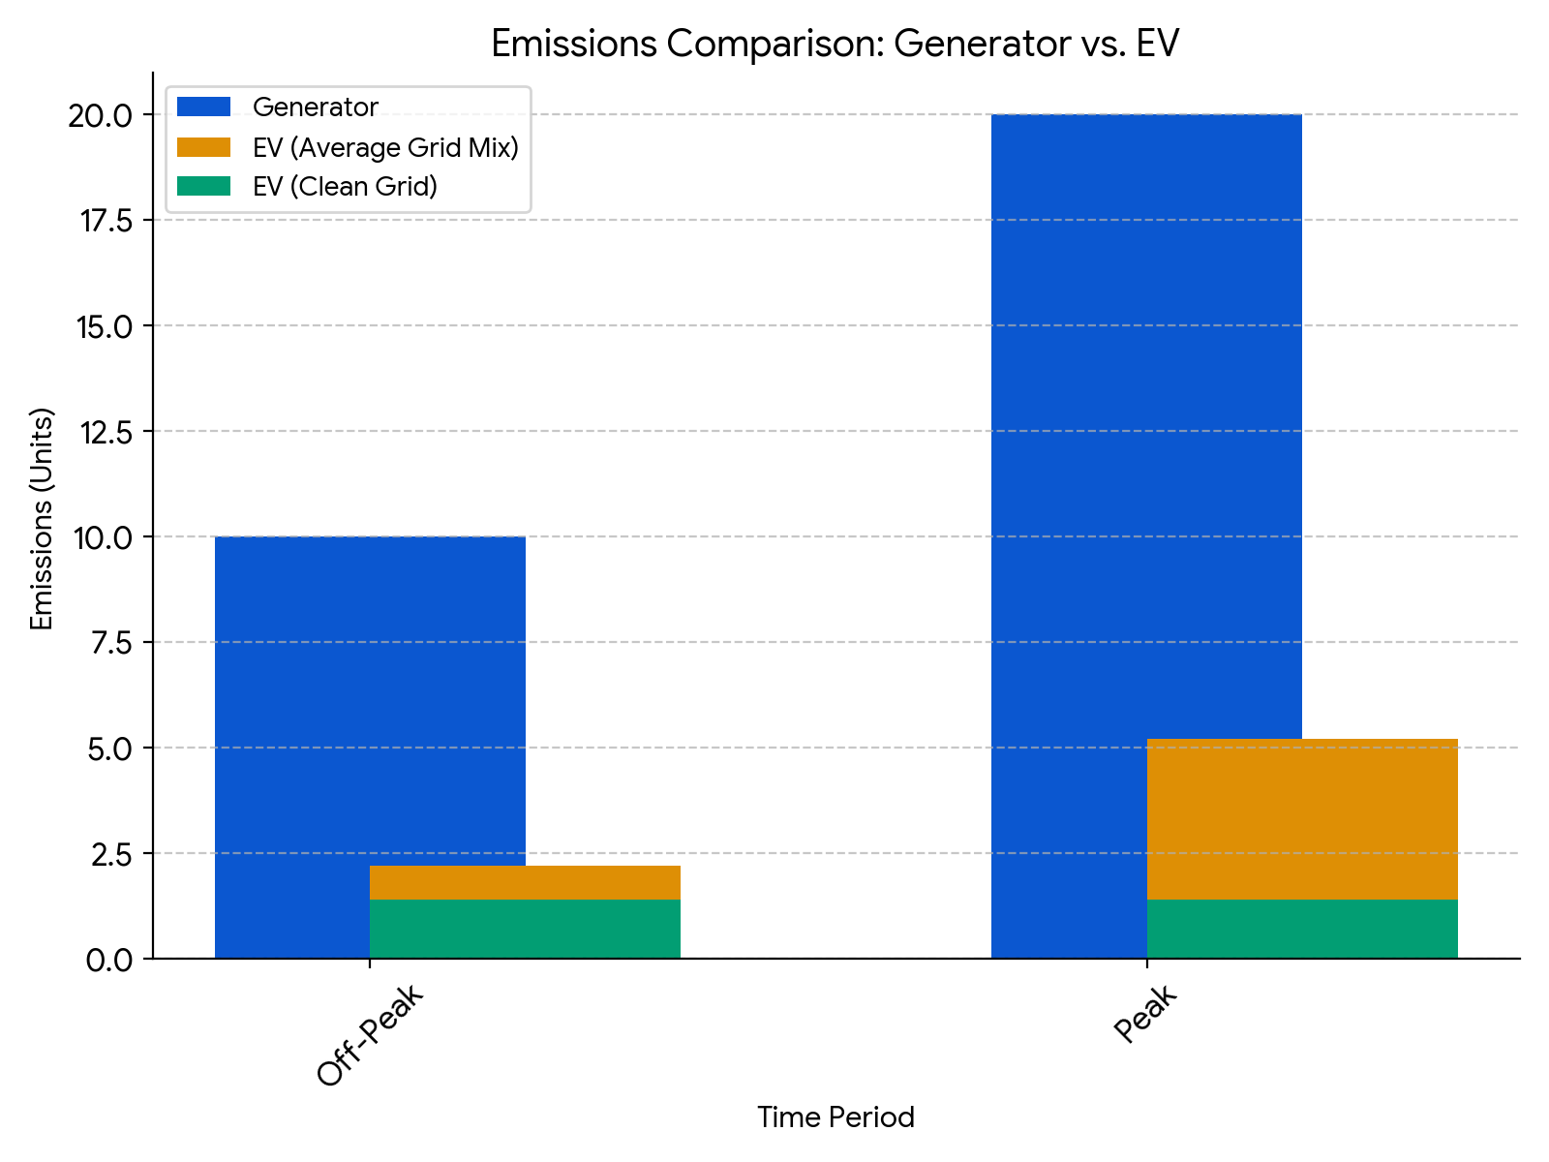

**Resource Depletion:**

* **Generators:** Generators rely on fossil fuels, a finite resource. Their burning contributes to climate change.
* **EVs:** Electric vehicles can be charged with renewable energy sources like solar or wind power, reducing reliance on fossil fuels.

**Summary of Environmental Benefits of EVs:**

* EVs significantly reduce air pollution and greenhouse gas emissions compared to generators, especially when charged with clean energy.
* They promote a shift towards renewable energy sources for a more sustainable future.